Artificial Intelligence

Lab 03
Topic | Advanced Python (Decorators, Generators, Context Managers, Lambda Functions)
Objective | Advanced Python  - Decorators.  - Generators.  - Context Managers.  - Lambda Functions.

Setting Up Environment

Step 1: Launch Jupyter Notebook
Once installed, you can launch the application from your terminal or Anaconda Prompt.
- Open your Terminal (Mac/Linux) or Anaconda Prompt (Windows).
- Navigate to the directory where you want to save your notebooks using the cd command (e.g., cd Desktop).
- Type the command jupyter notebook and press Enter.
- A web browser window should automatically open with the Jupyter Notebook interface.

Step 2: Create a New Notebook
In the browser interface, you can create a new Python notebook file.
- On the main dashboard, click the New button in the top right.
- Select Python 3 (or whichever Python kernel you have installed) from the dropdown menu to open a new notebook in a new tab.
- The new notebook will initially be named Untitled. You can rename it by clicking on the title text at the top of the page and typing a new name.

Step 3: Write and Run Code
Jupyter Notebooks are made up of cells. You can use two primary cell types: Code cells for writing and running Python code, and Markdown cells for writing formatted text and explanations.
- Select a cell by clicking inside it (a green or blue border will appear). New notebooks start with a code cell by default.
- Type your Python code in the cell. For example, type print("Hello World!").
- Run the code in the cell using one of these methods:
- Click the Run button in the toolbar.
- Press Shift + Enter to run the current cell and move to the next one (or insert a new one below).
- Press Ctrl + Enter to run the current cell and stay in place.
The output of your code will appear directly below the cell. You can continue adding new cells (by pressing the + button in the toolbar or B in command mode) to build your program interactively.
Step 4: Save Your Notebook
Jupyter Notebooks are automatically saved periodically, but you can manually save at any time.
- Go to File > Save and Checkpoint.
- The file will be saved with a .ipynb extension in the directory where you launched the server.

1. Decorators

In Python, decorators are flexible way to modify or extend behavior of functions or methods, without changing their actual code.
- A decorator is essentially a function that takes another function as an argument and returns a new function with enhanced functionality.
- Decorators are often used in scenarios such as logging, authentication and memorization, allowing us to add additional functionality to existing functions or methods in a clean, reusable way.

Example: Let's see an example in which a simple Python decorator adds behavior before and after a function call.

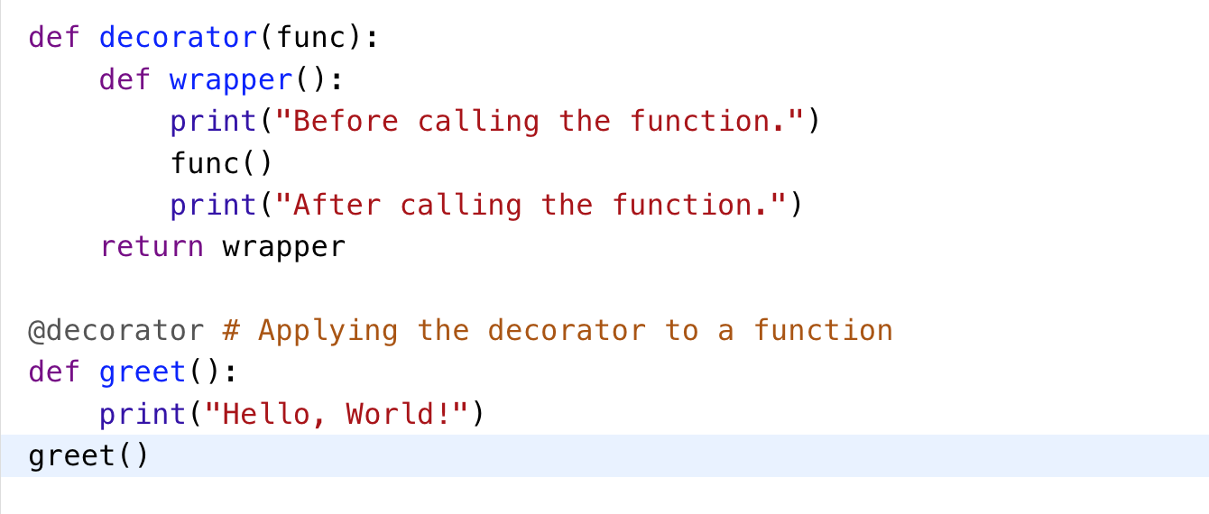
Output
Before calling the function.
Hello, World!
After calling the function.

Explanation:
- decorator takes the greet function as an argument.
- It returns a new function (wrapper) that first prints a message, calls greet() and then prints another message.
- @decorator syntax is a shorthand for greet = decorator(greet).

1.1 Decorator with Parameters
Decorators often need to work with functions that have arguments. We use *args and **kwargs so our wrapper can accept any number of arguments.
Example: Let's see an example of a decorator that adds functionality before and after a function call.
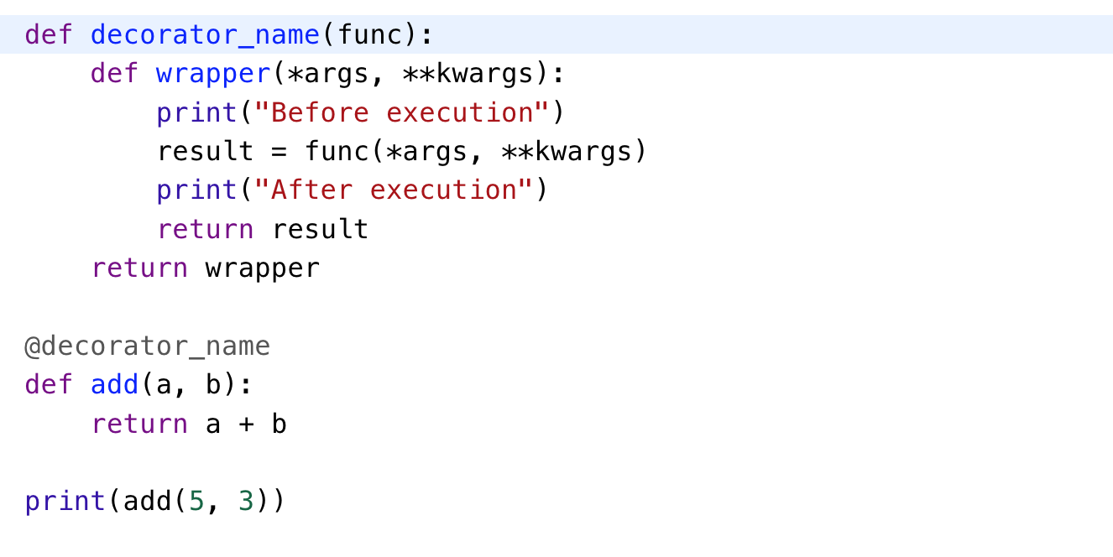
Output
Before execution
After execution
8

Explanation of Parameters
- decorator_name(func): This is the decorator function. It takes another function (func) as input.
- **wrapper(*args, kwargs): A nested function that wraps func. *args collects positional arguments, **kwargs collects keyword arguments, so wrapper works with any function.
- @decorator_name: Syntax sugar for add = decorator_name(add).

1.2 Types of Decorators

1.2.1 Function Decorators
The most common decorators in Python, used to wrap and enhance functions by adding extra behavior before or after the original function runs.
Example: In this Example, a decorator prints a message before and after executing wrapped function.

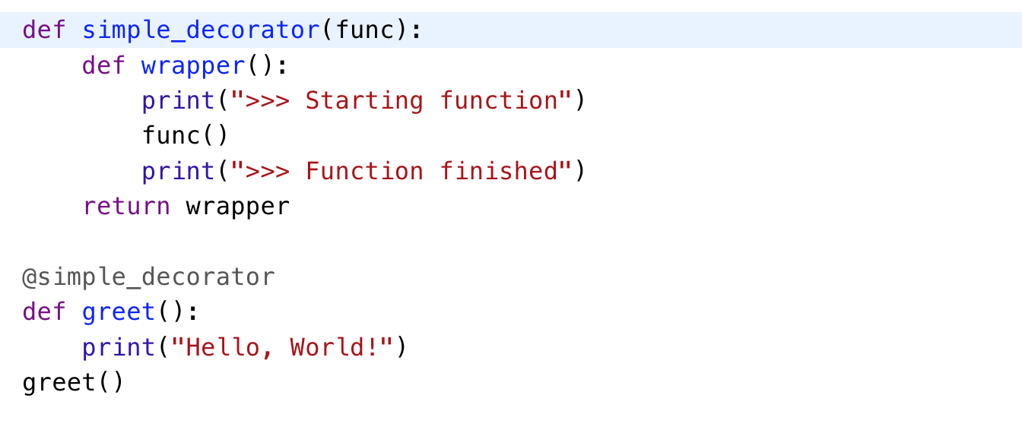

Output
>>> Starting function
Hello, World!
>>> Function finished
Explanation:
- simple_decorator(func): This decorator takes the function greet as an argument (func) and returns a new function (wrapper) that adds some functionality before and after calling original function.
- @simple_decorator: This is the decorator syntax. It applies simple_decorator to greet function.
- Calling greet(): When greet() is called, it doesn't just execute original function but first runs added behavior from wrapper function.

1.2.2 Method Decorators

Special decorators used for methods inside a class. They work like function decorators but handle the self parameter for instance methods.

Example: Here, a decorator prints a message before and after a method is executed, while correctly handling self argument.

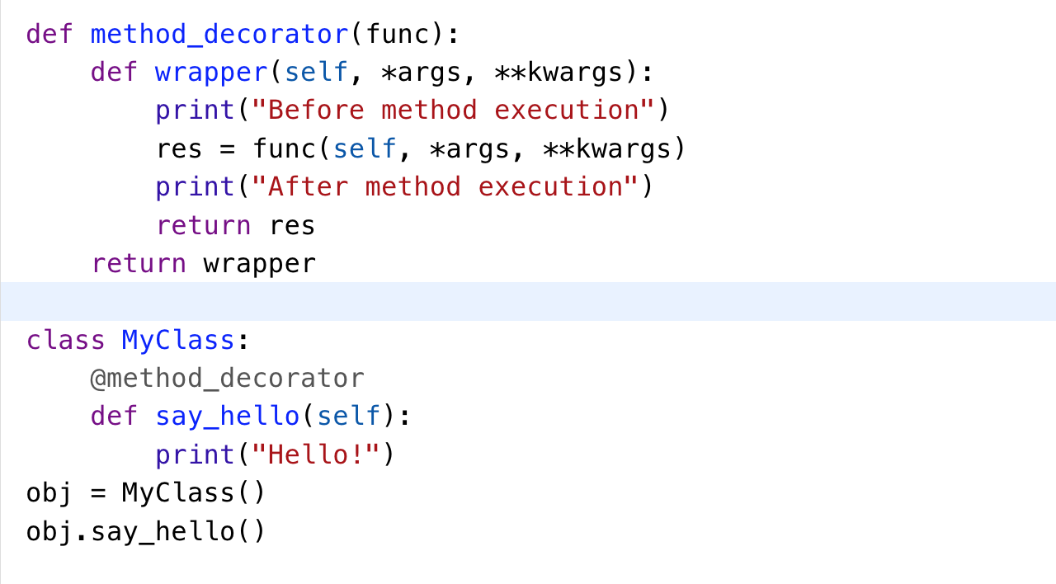
Output
Before method execution
Hello!
After method execution
Explanation:
- method_decorator(func): The decorator takes method (say_hello) as an argument (func). It returns a wrapper function that adds behavior before and after calling original method.
- wrapper(self, *args, **kwargs): wrapper must accept self because it is a method of an instance. self is instance of class and *args and **kwargs allow for other arguments to be passed if needed.
- @method_decorator: This applies method_decorator to say_hello method of MyClass.
- Calling obj.say_hello(): say_hello method is now wrapped with additional behavior.

1.2.3 Class Decorators
Class decorators are used to modify or enhance behavior of a class. Like function decorators, class decorators are applied to class definition. They work by taking class as an argument and returning a modified version of class.
Example: This code demonstrates a class decorator that adds a class_name attribute to a class, storing class’s name.

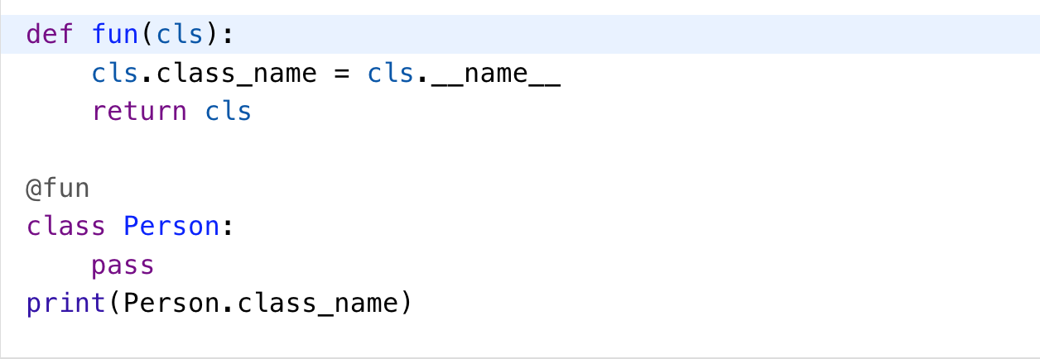
Output
Person

Explanation:

- fun(cls): This decorator adds a new attribute, class_name, to class cls. The value of class_name is set to the name of class (cls.__name__).
- @add_class_name: This applies the add_class_name decorator to the Person class.

Supplementary Reading on Decorators:
https://www.freecodecamp.org/news/decorators-in-python-tutorial/#:~:text=comprehensive%20blog%20here.-,Introduction%20to%20Python%20Decorators,the%20original%20function's%20source%20code.

2. Generators

In Python, a generator is a function that behaves like an iterator, producing a sequence of values one at a time using the yield keyword. This lazy evaluation makes them highly memory-efficient, especially useful for working with large or potentially infinite datasets without loading everything into memory at once.

Key Characteristics and Functionality
- yield vs. return: The primary difference from a normal function is the use of yield. While return terminates a function entirely, yield pauses the function's execution, saves its state (including local variables and the instruction pointer), and returns a value to the caller.
- State Preservation: When the generator is called again (e.g., in a for loop or with the next() function), it resumes execution from exactly where it left off, after the last yield statement.
- Iterators: A generator function, when called, returns a generator object, which is automatically an iterator (it implements the __iter__() and __next__() methods internally).
- Single Use: Generators can be iterated over only once. Once all values have been yielded and the generator is exhausted, a new generator object must be created to iterate again.

Ways to Create Generators
- Generator Functions: Defined like regular functions, but they use yield instead of return.

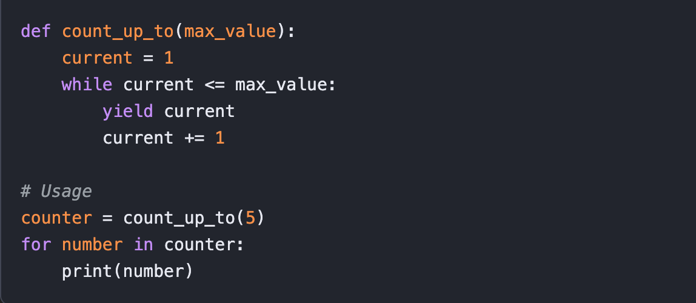

The output would be:

1

2

3

4

5

- Generator Expressions: A concise, single-line way to create generators, similar to list comprehensions but using parentheses () instead of square brackets [].
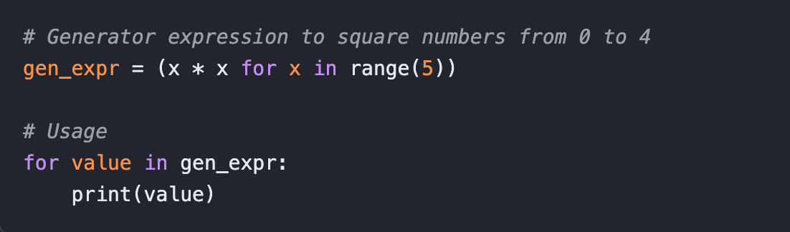

Why Use Generators?
- Memory Efficiency: The main advantage. Generators produce items on the fly and don't store the entire sequence in memory, making them ideal for large datasets or file processing.

- Infinite Sequences: Since values are generated on demand, generators are the only way to represent and work with infinite data streams (like an endless sequence of natural numbers) in a memory-safe way.
- Pipelining: Multiple generators can be chained together to form efficient data processing pipelines, where the output of one generator feeds into the next.
- Cleaner Code: They simplify the implementation of iterators, as the boilerplate code for managing iteration state (__iter__(), __next__(), StopIteration handling) is managed automatically.

3. Context Managers

A context manager in Python is an object that guarantees the automatic setup and teardown of resources, even if errors occur during the process. The most common way to use a context manager is with the with statement, which replaces repetitive try...finally blocks with cleaner, more readable code.

How They Work

Context managers operate based on a simple protocol that involves two special methods:
- __enter__(): This method is called when the execution enters the with block. It sets up the resource (e.g., opens a file, establishes a database connection) and returns the resource to be used within the block (usually assigned to a variable using the as keyword).
- __exit__(exc_type, exc_value, traceback): This method is automatically called when the execution leaves the with block, regardless of whether an exception occurred. It handles the cleanup logic (e.g., closing the file, releasing a lock). The arguments receive information about any exception raised within the block, allowing the context manager to handle or suppress the error if necessary.

Common Uses

Context managers are used in many scenarios beyond simple file handling:
- File Handling: The most common example is ensuring a file is closed after use.

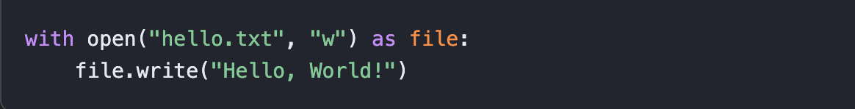
- Database Connections: Managing the lifecycle of database connections and ensuring they are closed.
- Concurrency: Acquiring and releasing thread locks safely.
- Temporary State Changes: Temporarily changing a global setting (like a working directory or decimal precision) and automatically restoring the original state.
- Testing: Automating setup and teardown operations in unit tests, such as mocking API responses or creating temporary directories.

Creating Custom Context Managers

You can create your own context managers in two ways:
- Class-based: By defining a class with the __enter__ and __exit__ methods.
- Function-based (using contextlib): For simpler cases, the contextlib module provides a @contextmanager decorator to turn a generator function into a context manager, using a yield statement to separate the setup and teardown logic.

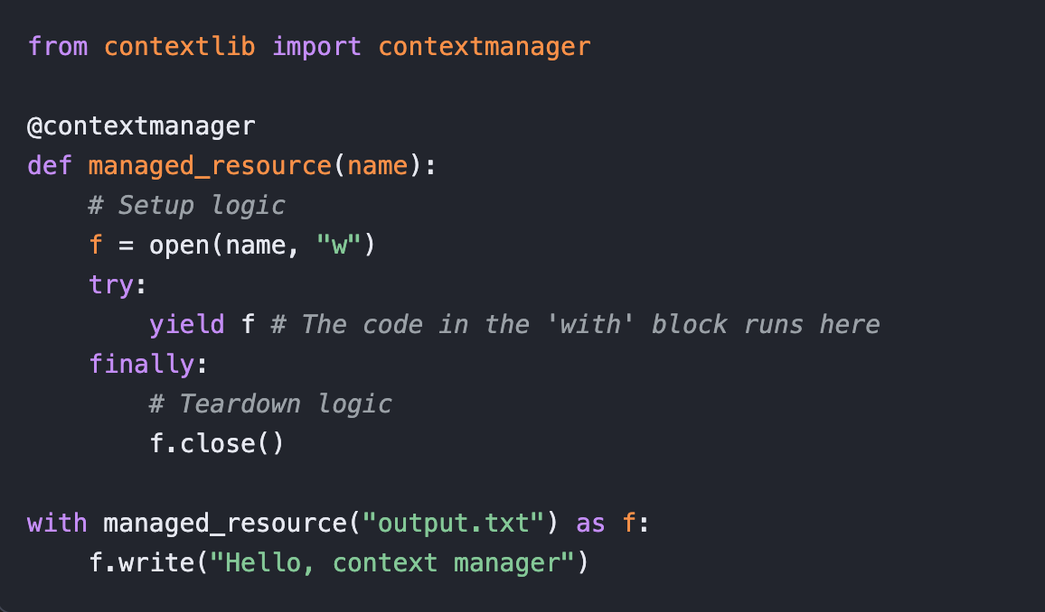

Using context managers makes code more robust, readable, and less prone to resource leaks.

4. Lambda Functions

A lambda function in Python is a small, anonymous function that can take any number of arguments but is restricted to a single expression. They are defined using the lambda keyword and are primarily used for short, one-time operations, often as arguments to higher-order functions.

Syntax
The basic syntax of a lambda function is:
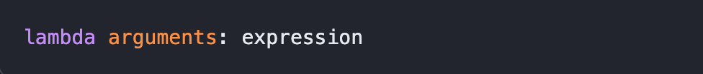
- lambda: The keyword to define the anonymous function.
- arguments: A comma-separated list of input parameters (can be zero or more).
- expression: A single expression that is evaluated, and its result is automatically returned. No return statement is used.

Examples
- A simple lambda function that adds 10 to an argument:
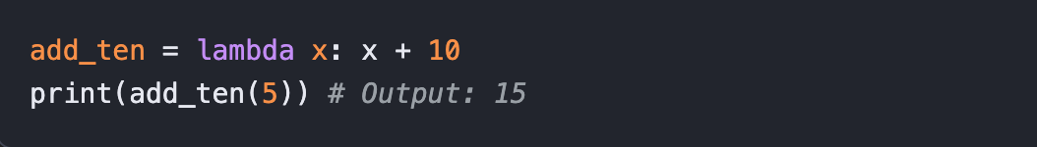

- A lambda function that multiplies two arguments:
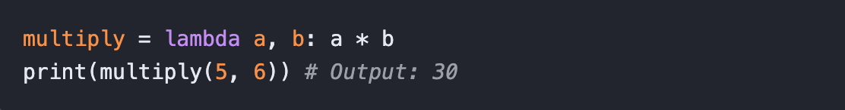

- A lambda function with conditional logic:
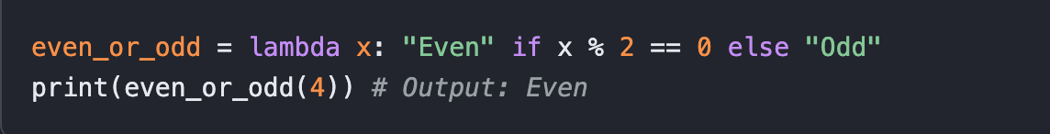

Common Use Cases
Lambda functions are most powerful when used inline with built-in functions that accept a function as an argument, such as:
- map(): Applies a function to every item in an iterable.
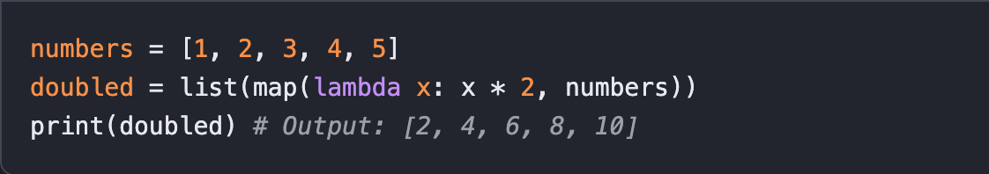
- filter(): Creates a list of items for which a function returns True.
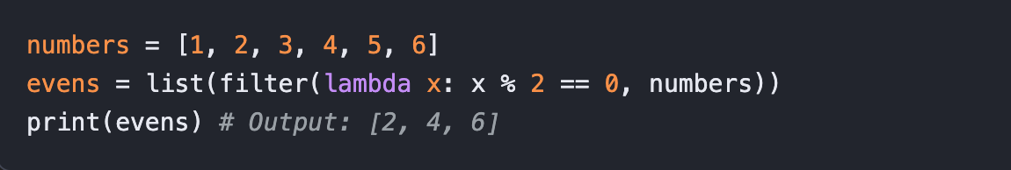
- sorted(): Sorts an iterable based on a custom key function.
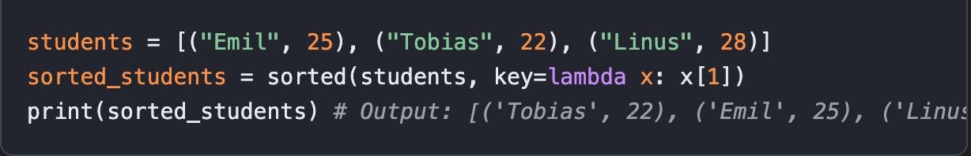

Limitations
- They can only contain a single expression.
- They cannot include statements like if, for, while, or raise.
- They cannot have a docstring or type annotations, which can impact readability for complex logic.

Lab Tasks

Task1: Execution Timer Decorator CLO1
Create a Decorator named @time_it that measures the time a function takes to execute. Apply this to a function that computes the sum of squares for all numbers up to 10 million.
Note: You can use time.perf_counter() for high-precision timing.

Task2: The Multi-Criteria Sorter CLO1
Given a list of tuples representing students (Name, Grade, Age), use a Lambda function with sorted() to sort the list primarily by Grade (descending) and secondarily by Age (ascending).
Note: Take a list of five students.

Task3: Memory-Efficient Fibonacci CLO1
Write a Generator function that yields the Fibonacci sequence up to
terms. Demonstrate its memory efficiency by "looping" through the first 100 terms without creating a 100-element list.

Task4: The Secure File Manager CLO1
Create a Context Manager (either as a class or using @contextmanager) that opens a file, converts all incoming text to uppercase before writing it, and ensures the file is closed even if an exception occurs during writing.

Task5: CLO1
Answer in your own words:
- For a Decorator to work, it relies on a functional programming concept called a "closure." Explain how the inner wrapper function retains access to the func argument even after the outer decorator function has finished executing.
- Why are Lambda functions in Python limited to a single expression rather than multiple statements? Contrast this with a standard def function in terms of its return behavior.
- In a Generator function, what exactly happens to the local variables and the instruction pointer when the yield keyword is encountered, and how does this differ from a standard return?
- When using a Context Manager via the with statement, which specific "dunder" (double underscore) method is responsible for handling exceptions that occur within the block, and how can it prevent an exception from propagating?

